University of Technology, Jamaica

Faculty: Engineering and Computing

School: School of Computing and Information and Technology

Academic Year: 2018/19

Semester: 2

Module: Advance Programming

*Group project on Right Now Taxi Service User Manual*

Group Members:

Duran Thomas - 1401134  
Daniel Dixon – 1403732  
Crystal Clarke - 1603317  
Alicia Harriott – 1104334

**__________________________________________________________________**

Tutor: Mr. Gilroy Gordon

**System Overview**

Right Now Taxi Service provides a web application with a client and server side login with a database that maintains information. From the client side users must first register with their credentials. After registration a user can login with a generated user profile. A user can perform the following: Request a Cab and Make a Query from either (tour service/ /support/other).

From the Cab Manager’s end, an Admin is privileged to view a summary report of total distance travelled and total amount earned for each cab. Also, the Admin should be able to view a report of all cab request that were not successful; commission and decommission cabs.

***Home Page***

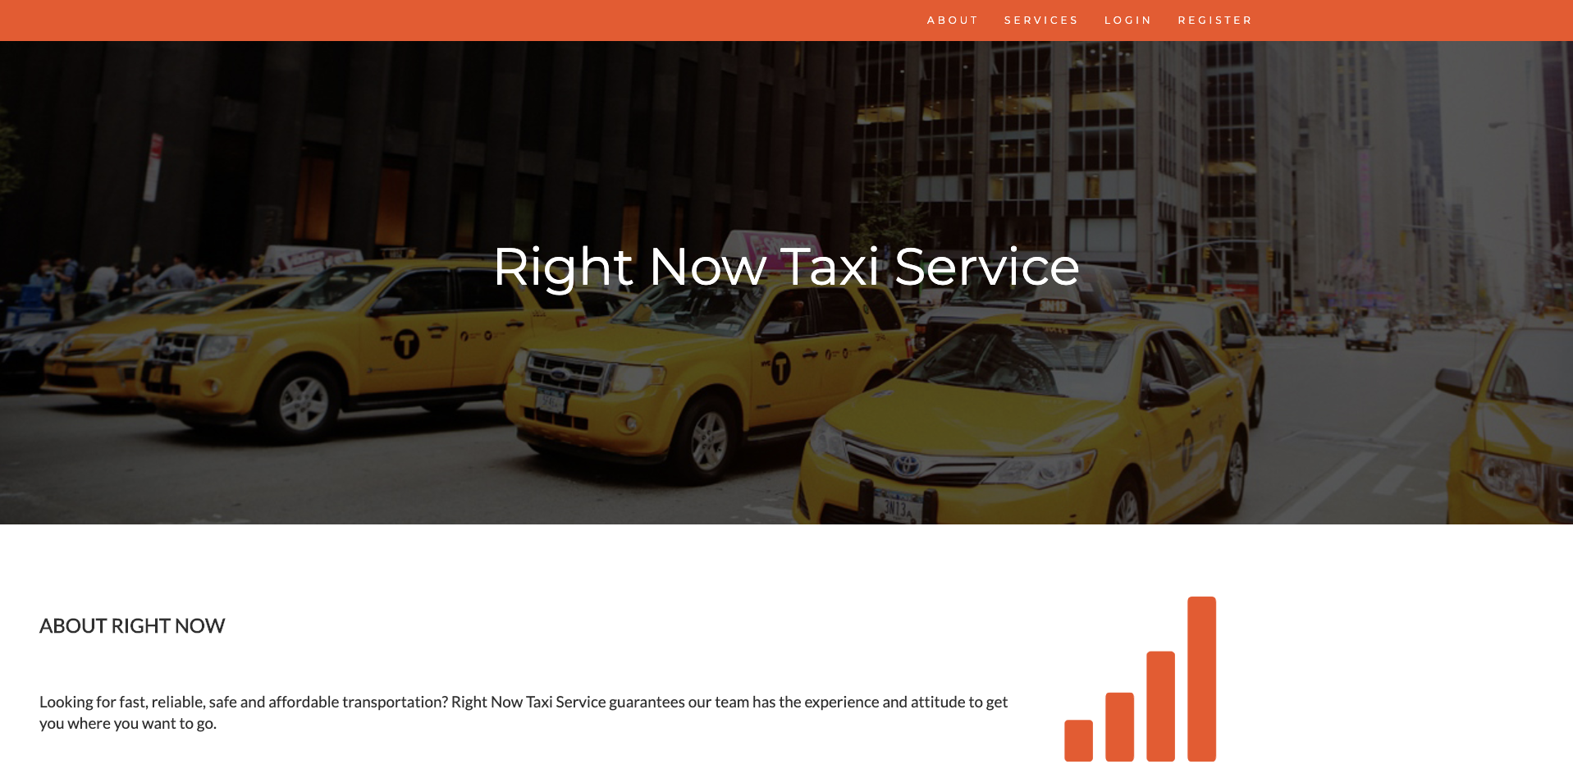

This is the front page for both a customer and the cab manager. It contains the “About Us, Services, Login and Register Tabs.”

***Services***

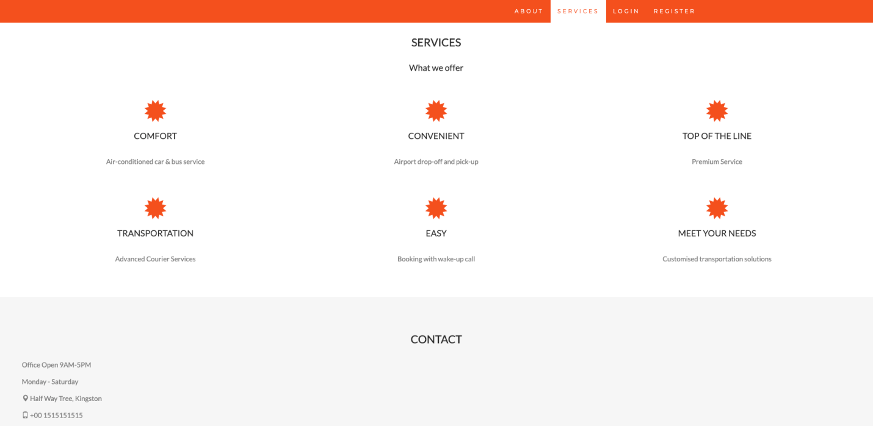

This page showcases the type services customers will receive which depict the quality of the brand.

***Registration Page***

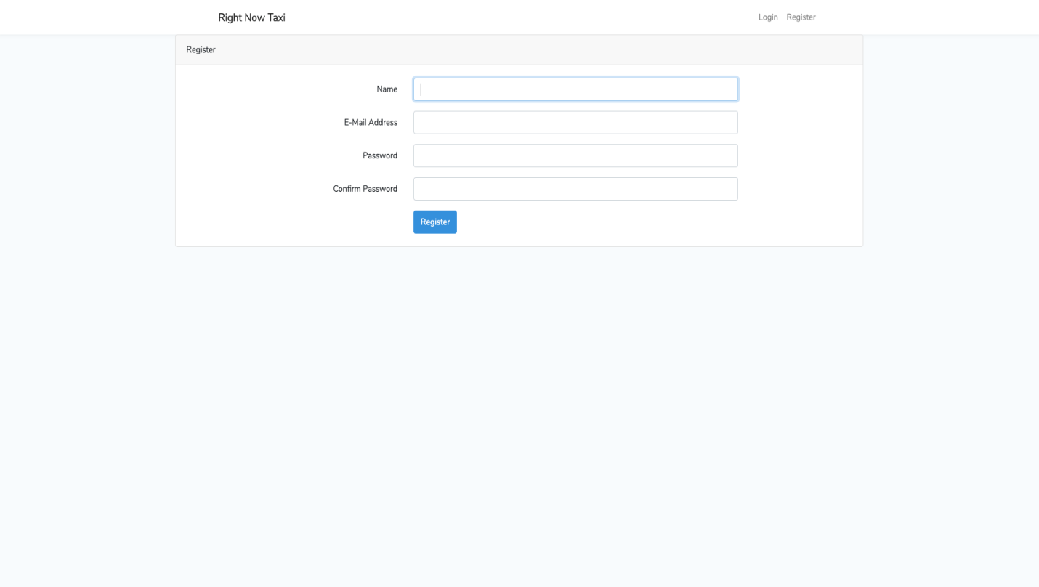

This page captures customer’s credentials for registration.

***Login Page***

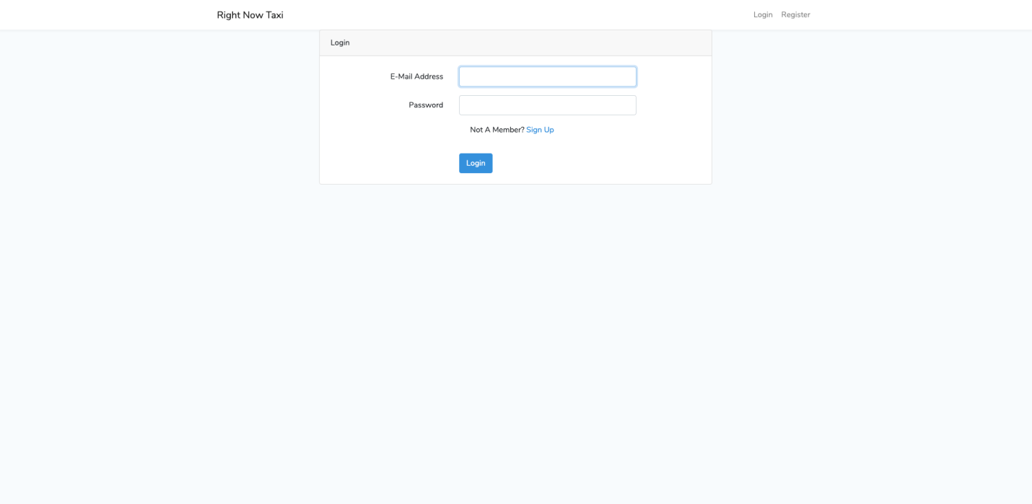

Customers who have registered will login from this page.***Customer Login Page***

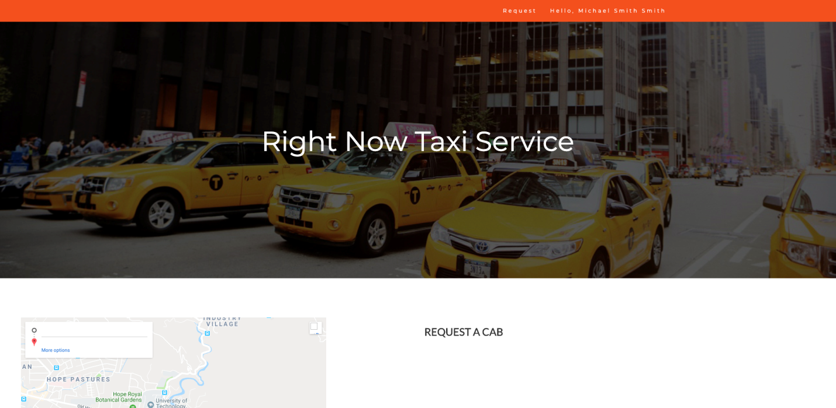

This page is customizing for a customer where a customer is welcomed to the company’s service.***Request a Cab Page***

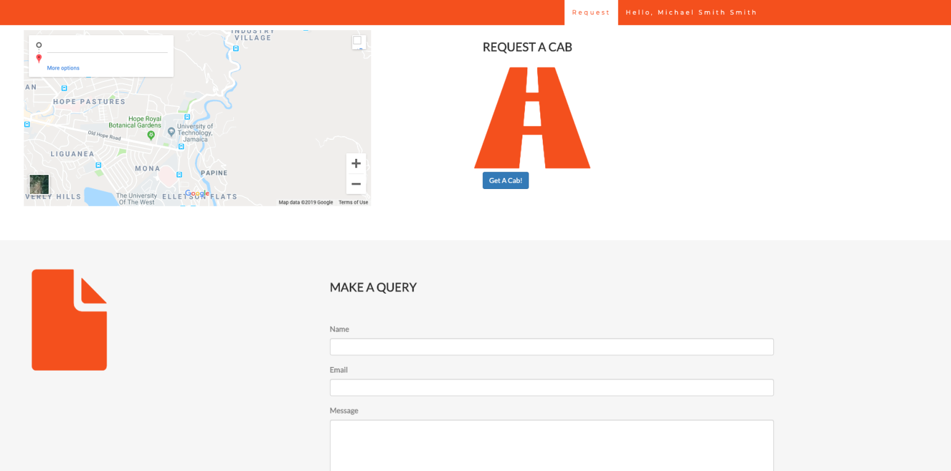

A customer makes a request for a cab by hitting the “Get A Cab” button which then links to the Confirmation Page.

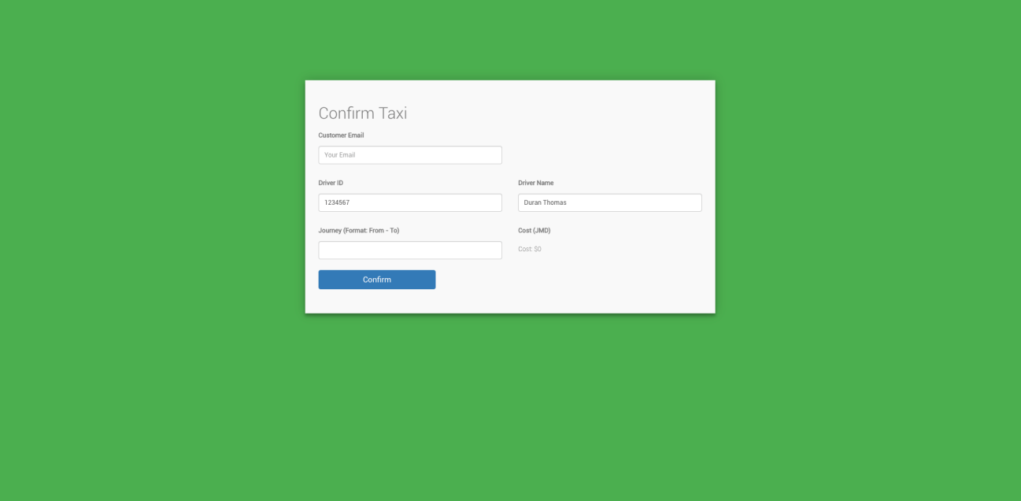**User Request**

This is where the user will make a request for a cab by giving their email address and their journey from and to and then confirm that request with the Drivers ID and Drivers Name by just clicking the confirm button for confirmation.

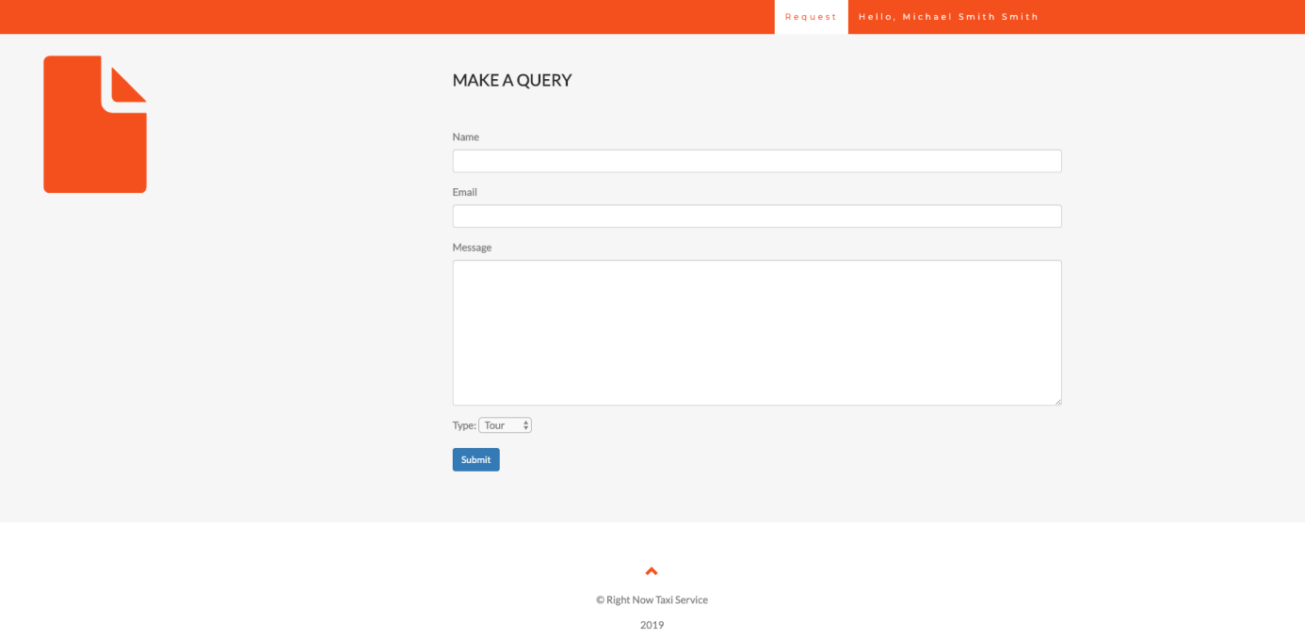

**Customer Service**

The customer of this service is able to leave a message for a customer service representative to respond to later by email. In doing this customers are required to insert their full name, email address and a message about the query, also they can select a type and then click submit for submission.

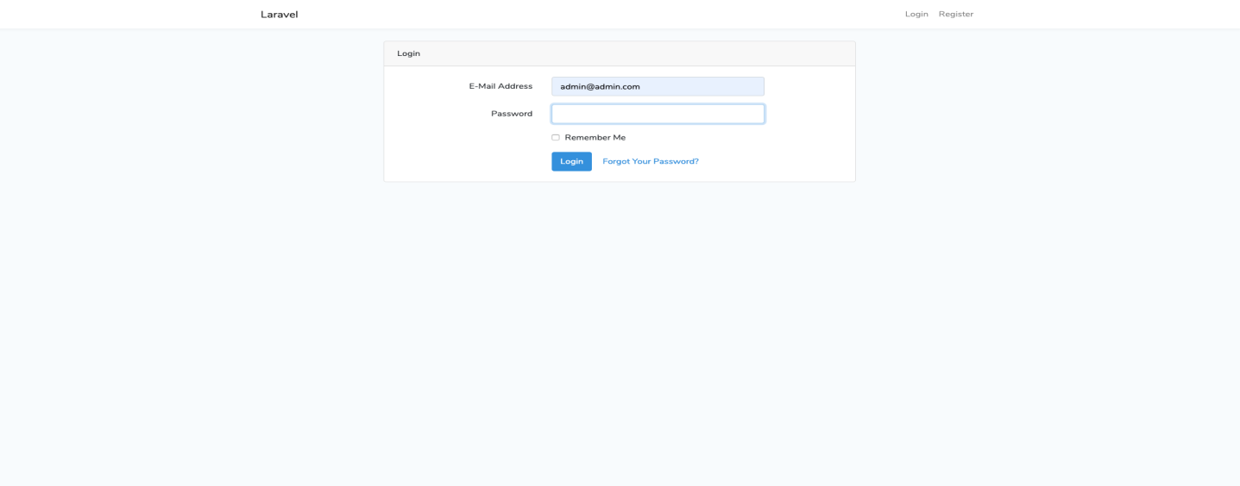Administration Login Area

This area is only authenticated to administrative personnel’s and of such an email address and password is required to gain access to the administrative dashboard just by clicking login. Also if email or password is forgotten or needs to be changed there is a “forgot your password” feature for this.

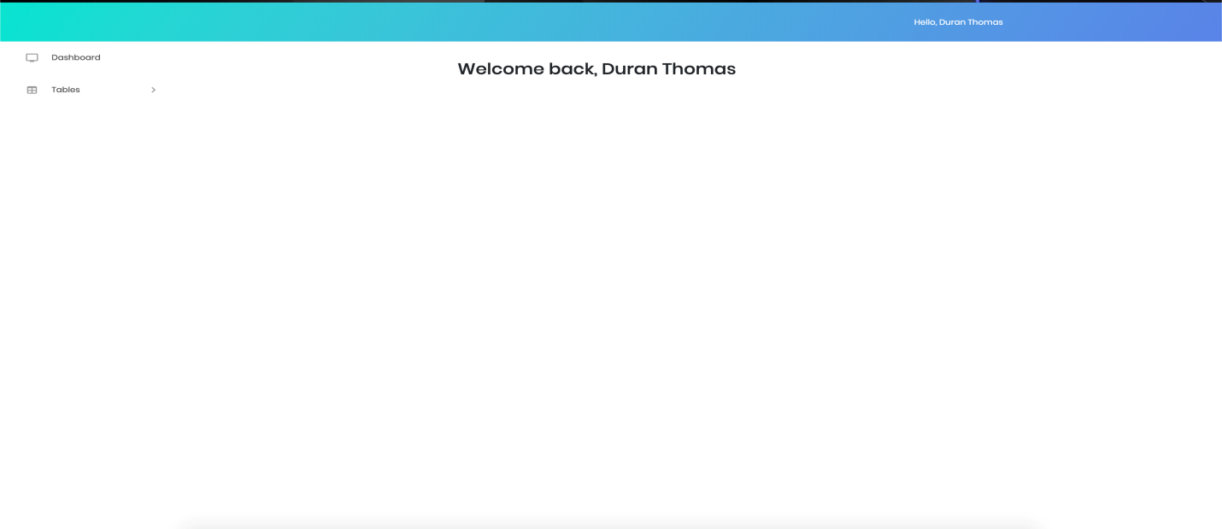Admin Dashboard

This is the administrative panel/profile where the admin can view customers’ requests and view the history’s journey and cost.

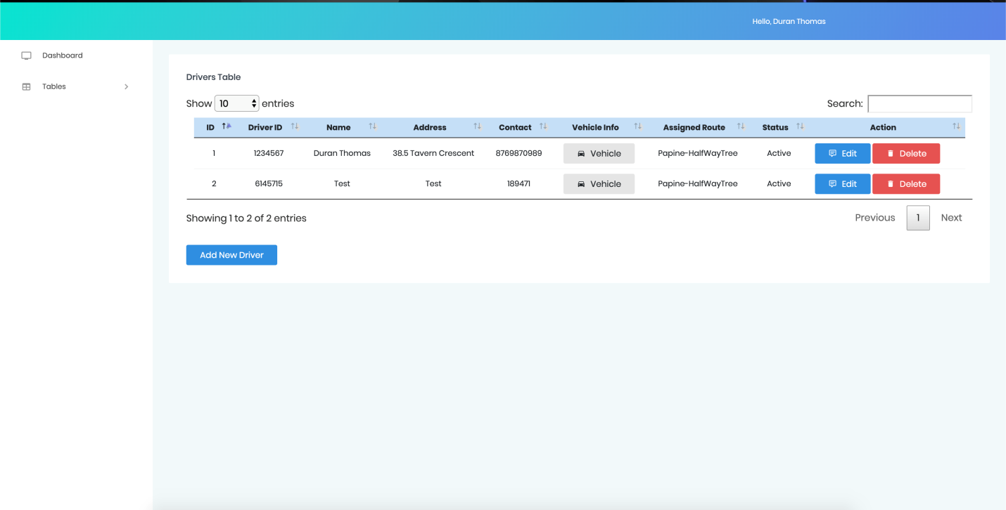

This is a view of where the admin can actually see the driver’s information and is able to update or delete information base on what is required by just clicking the edit button for editing and delete button for deleting.